S1a

**Scenario 1**: The starting salary of an accountant after graduation is £26,000 according to The Telegraph. The accountant can afford a car loan of the sum £4000. Furthermore, if this person’s current account is linked with Barclays then its current account interest would be at 3% according to its website. Finally, this accountant housing rent would be £589 if we assume this person is living outside inner London.

**Scenario 2:** A social engineer can earn on average is **£50,000** According to the ’save the student website’. A social engineer can afford a £7000 car loan with 4.2% rate. Also, this persons housing rent would be relatively £1500 monthly if we assume this person lives in London. Finally, if this person with Barclays bank then its current account interest would be 3% according to Barclay’s website.



From this figure it can be shown that it would take 5.6 years or 68 months to fully repay the car loan for the accountant with given interest of 4.2% if we use AutoTrader rate.

30 years

15 years



For scenario 2 if we plot all three accounts together we can see that the current account grows exponentially if we consider 30 years and this causes the other two accounts not be readable if we just look on the same figure and for scenario 1 this is an also a similar case. Therefore, in the code I have used subplots instead where it allows us to read the 3 accounts separately. The subplot function differs from the plot command because a subplot is given in the form subplot (m, n, and p) where it divides the current figure into an m-by-n grid and creates axes for a subplot in the position specified by p. furthermore, both of these data can be distinguish as the student loan for 15 years grows exponentially and for the 30 year it tends to repaid before 200 months.

S2a

http://latex.codecogs.com/gif.latex?N%20%3D%5Cfrac%7Brx%7D%7B1-%281&plus;r%29%5E%7B-n%7D%7Dhttp://latex.codecogs.com/gif.latex?n%20%3D%20-%5Cfrac%7Bln%28%5Cfrac%7BN-rx%7D%7BN%7D%29%7D%7Bln%281&plus;r%29%7D

This formula which is similar to the formula from the given session hand-outs was derived by rearranging the formula above (right hand side). Therefore, N is the monthly repayment; x is the interest rate on the car loan; and r is the amount of loan and it is multiplied by minus one so it the number of months is positive. This formula gave me accurate response for one of my realistic scenarios.

In this question the formula was added to the code; where two new variables were defined because if I use one variable I would probably wrong. Also, if you put the formula in the loop part of the car loan then it would not work. I have also used sprint which is the same as fprintf except that it returns the data in a MATLAB string variable rather than writing it to a file. I have used str2double ass Z Is a complex scalar and it is needed for me to use the ceiling functions in order to round it to 68 months.

S2B:

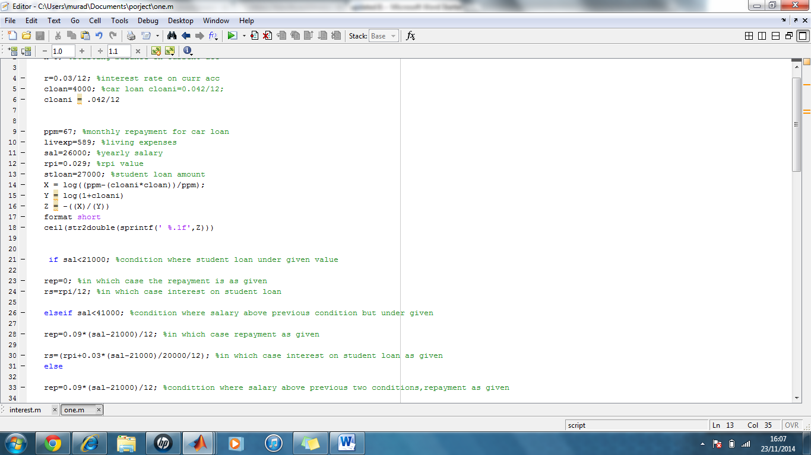

S2C

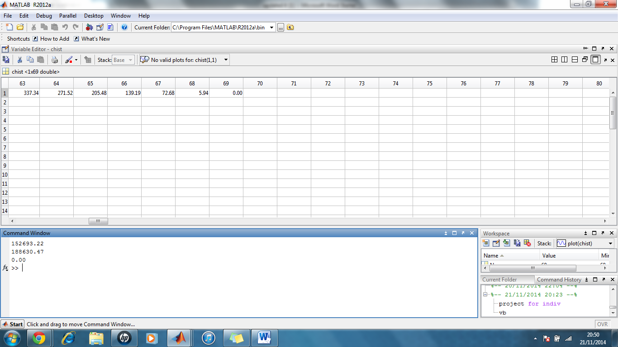

S2C: I can reiterate that the formula is correct as I chose my monthly repayment as £67 and 68 months is needed to cover the repayment fully. This can be shown by opening the Chist in the window where it shows how is paid each month.

In this loop part of the programme, for loop was used; the timeline is from 1 to 67 where it needs to print the last month payment. If and else statements were used because it needs to check whether car loan is less than the monthly repayment and else statement will accumulate a further traction if the criteria is not met. Thus, in the command window automatically the final payment is shown; in my scenario the value is £5.94 which is the 68th month.

I also used fprintf function towards the end in order for the program to execute the value and this function is more flexible as it allows me to control the amount significant figures.

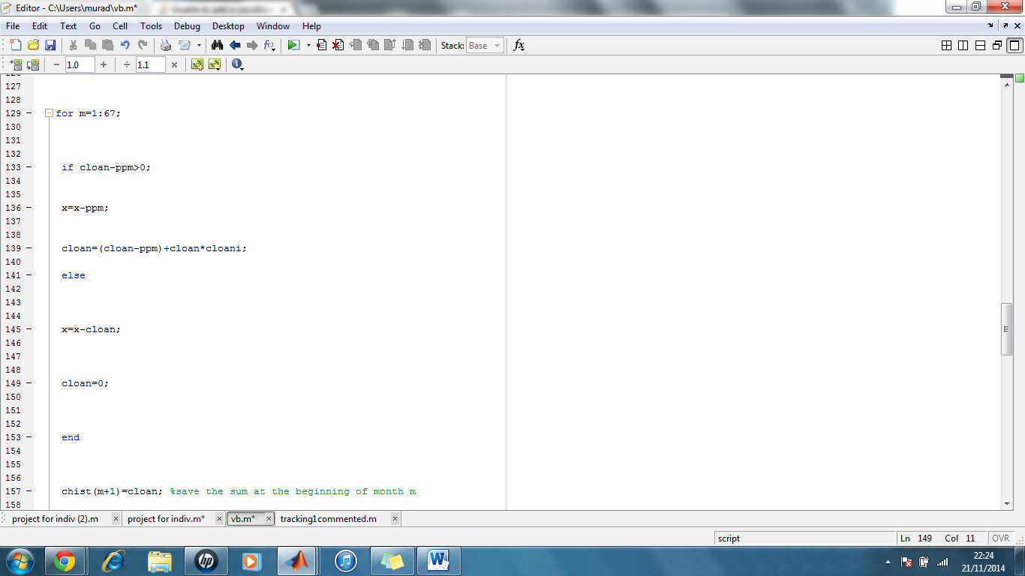

C1A: